SunFlower Helicopter Rocket
LUNAR Build Session: 9/25/08
By Tom Desmarais

Contents of Kit:
A. 3 1/16”x1”x11” basswood rotors
B. 3 1/16”x2”x2” basswood fins
C. 3 1/16”x5/16”x1/2” basswood hold spacer
D. 3 1/16”x5/16”x1” basswood holds
E. 3 1/16”x1/16”x1” basswood spacers
F. 3 1/16”x1/16”x3/4” basswood spacers
G. 3 1/16”x1/4”x4 3/16” basswood stops
H. 3 .025”x1/2” wire rear hooks
I. 3 .025”x1/2” wire front hooks
J. 1 11 ¼” (some are 11”) bt20 body tube
K. 1 bt20 balsa nosecone
L. 1 swivel hook
M. 1 small eye hook
N. 1 6” Kevlar string
O. 4 rubber bands
P. 6 ¾”x1” strapping tape pieces
Q. Shock cord mount
R. 18mm Thrust Ring

Also Needed:
Thin CA glue
Med CA glue
CA accelerator
Yellow wood glue
5 min Epoxy
Hobby knife
Metal Ruler
Sandpaper
Emory board
Pencil
Masking tape
Wax paper
Toothpicks
Cutting Mat
Used 18mm Motor
Wood Skewers
Paint

Jigs Supplied:
Fin spacer jig
Fin alignment jig
Rotor/Hook template

Goals:
I really enjoy flying helicopter recovery rockets, and I wanted an easy to build, and reliable design that I could share with everyone. I’ve built four or five different helirocs, and most that I’ve flown more than once have had no-deploy failures at some point. Most of these were competition helirocs, which have blades that open up and use a string that burns through to hold the rotors against the body. If the delay on the motor is too long, and the rocket is already heading down, the force of the wind can keep the rotors from deploying and the rocket will prang! I knew I wanted a design that would be safe even if the rotors didn’t deploy correctly. Also, the burn string method makes prep a bit of a chore. It’s fine for competition, but for sport flying, I’d like something quicker and easier.

I also wanted to keep the parts list down, which turned out to be difficult. Anytime you have moving parts, the parts count seems to go up quickly. I was able to use one size of wood, to try to simplify the purchasing part. I used basswood for its strength, since I wasn’t trying to make a competition model, and I wanted it to be robust. I also wanted to be able to use larger motors, so having stronger materials made that less likely to shred. I chose 18mm body tubes to allow a larger selection of motors.

I originally was hoping that there wouldn’t need to be any hooks or rubber bands. When I flew that prototype, the rotors deployed, but wouldn’t stay deployed. If one of the rotors didn’t fold out completely, the SunFlower would be unstable and not start spinning. It still came down safe and tried to spin, but it never attained a good solid spin. So I added hooks and rubber bands. The next flight, the rotors deployed perfectly, and the SunFlower rotated, but the long shock cord with a nose cone on the end kept twisting and kinking, throwing the SunFlower sideways and interfering with a nice helicopter spin. So, I shortened the shock cord a bunch. The next flight, the SunFlower came down in a nice tight spin with no damage.

How it works:
The moving parts on the SunFlower are the nose cone and the rotors (and of course the whole rocket!). The rotors lie flat against the sides of the rocket between the fins. The rotors have a hinge made of strapping tape near the rear of the rocket. The nose cone has three holds on it that hold the rotors at the top of the rocket to keep them from deploying on the way up. Rubber bands attach to the rotors and the rear of the rocket to force the rotors to open when the nose cone is kicked off by the ejection charge. The rotors are opened and come to a stop against stops that go between the fins at the back of the rocket. The rotors have dihedral, meaning they sweep back from the rocket, to give stability when coming down. The hinges on the rotors are also angled, so when deployed, the rotors are slanted to the direction of travel. This will cause the SunFlower to spin as it falls. The nose cone is attached by a short shock cord so we don’t lose it.

Building:
- Install the thrust ring. Apply glue inside the body tube 2 ½” from the end using wood skewer. Using a used motor, push the thrust ring in so ¼” of the motor remains outside tube. Remove the used motor.
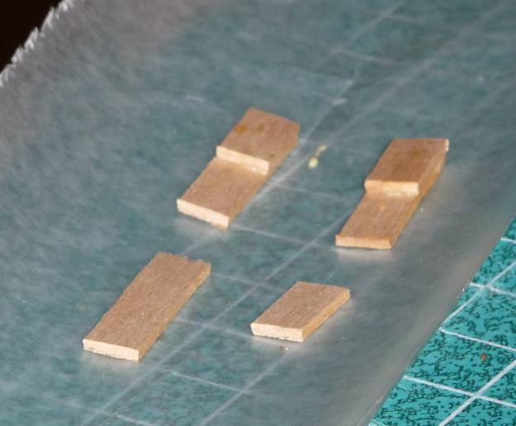
- Make the rotor holds. Take one of C and D, align them together and glue with yellow glue as shown. Repeat with other two pieces.
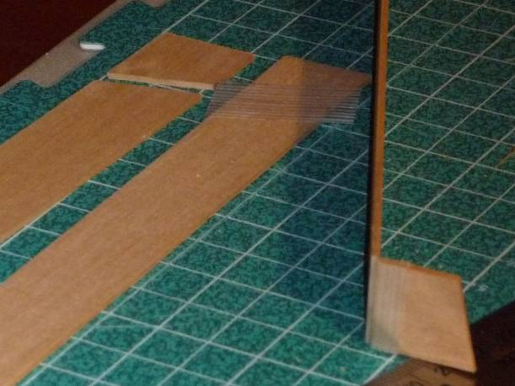
- Make the rotors. Take one of A. Put the rotor template on one end, and draw a line for where to cut. The cut should start ¾” from an end and go to 1”. Cut the rotor along the line with the blade perpendicular to the rotor. Holding the two rotor pieces together with the rotor going away from you, with the shorter side to your left, put one of the pieces of strapping tape too join the pieces. Center the tap along the joint. Use your fingernail to ensure the tape is well bonded. Fold the rotor at the joint back onto itself so that the edges of the joint match. Use another piece of tape over the ends of the wood and press it down over the rotor. Trim the tape where it sticks out the sides of the blade. Ensure that the hinge is strong and flexible. Repeat for the other two rotors. Note: It is very important that all of the rotors open the same way.
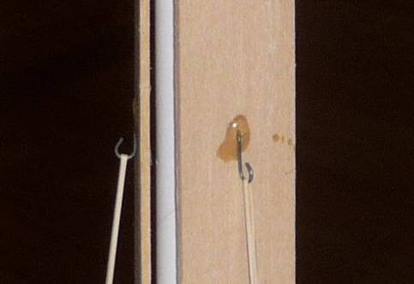
- Put the rotor hooks on. Use the Hook template to mark the rotor where the hole for the hook should go. Use the end of the hook to “drill” a hole for the hook through the rotor. Push the hook through the rotor and align so the open part of the hook is pointed away from the hinge. Use a drop of Med CA to glue the hook in place. Repeat with the other two rotors.
- Prepare the fins with the spacers. The fins have 1/16”x1/16” spacers glued to each side to help support and align the rotors when they are glued on. The spacers also giver room for the launch rod inside the rotors and act like a launch lug. Use the Fin Spacer Jig to mark the fins. Note that one side is marked to take the shorter piece.. Take one of E, F, and B. Take E and place it on the left side of the fin in the jig. Use a very small amount of yellow glue to glue it in place. The spacer should be flush with the rear of the fin and below the line from the jig (towards the bodytube). Take F and repeat on the right side. 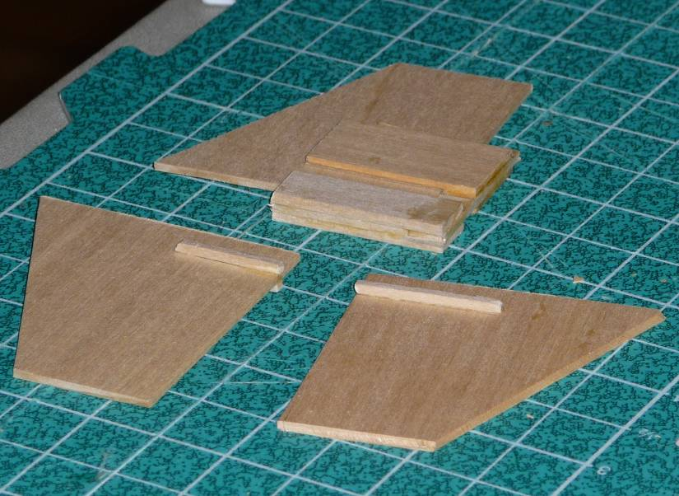 Repeat with other two fins. Ensure the spacers are on the correct sides.
- Glue the fins to the bodytube. Place the bodytube on the Fin Alignment Jig. Note that due to quality control issues, there are two sizes of tubes, 11 ¼” and 11”. The 11 ¼” tubes have the fins mounted ¼” from the rear as shown below. The 11” tubes have the fins mounted flush with the bottom. The rotors are 11”, so it is easy to check which one you have. Take one of the fins and use a clamp to hold it to the fin alignment guide against the body and base of the guide. Dribble a small amount of thin CA at the top of the fin, allowing it to seep down. Run a small amount of CA down one side of the fin (don’t use so much that it dribbles down). Use accelerator to ensure the CA has set, remove the clamp, rotate the tube so the fin aligns with the guide, and clamp another fin to the guide. Glue this fin in the same way, then repeat the process for the last fin. 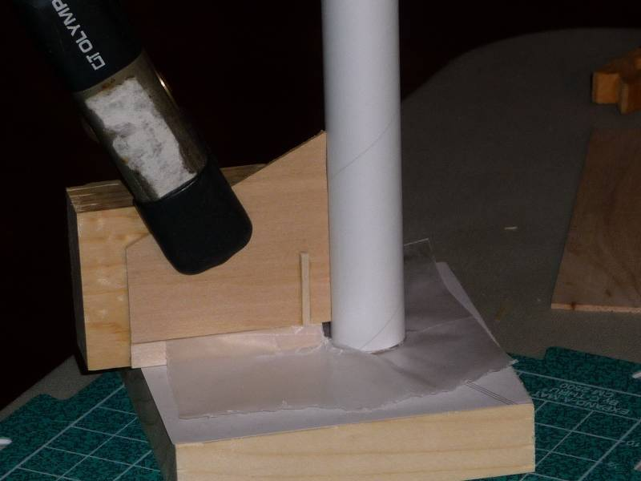 After all of the fins have set, run a small amount of CA down the other side of each fin. When that has set (you can use accelerator), make some small fillets with yellow glue on each side of each fin. 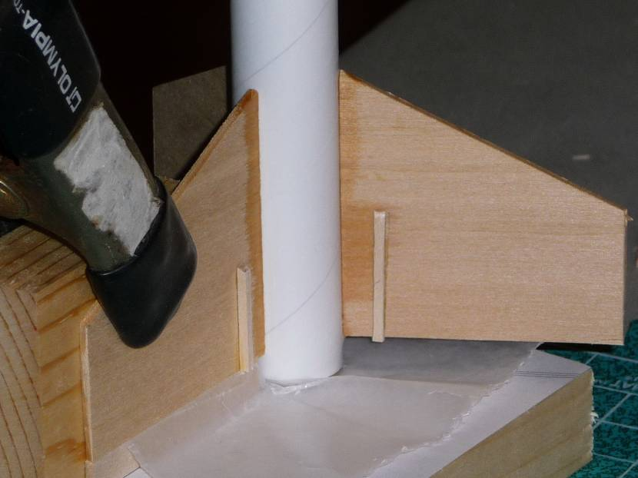
- Glue the rotors to the fins and bodytube. Take one of the rotors and trial fit it between two of the fins. It should sit against the bodytube as well as the two spacers on the fins. Note that the rotor has to go on one way, so the different length of the spacers match the length of the rotor cut. If the spacers hold the rotor above the bodytube, sand them down to allow it to touch the bodytube. If the rotor doesn’t reach one of the stops and isn’t close, add a shim of basswood to fill the gap (add a shim to both sides to keep rotor balanced. If it is only a small amount off, glue can fill the gap. The rotor will not reach the fin. Apply yellow glue to the bodytube where the rotor will touch, but not near the hinge line. Use masking tape on the top part of the rotor to hold it to the bodytube, with the top of the rotor aligned with the top of the bodytube. Use masking tape at the bottom to hold the rotor down. The bottom of the rotor should align with the bottom of the fins. Apply CA to where the two spacers contact the rotor. Don’t get CA near the hinge. It is very important to not glue the long part of the rotor to anything as well as not getting any glue in the hinge joint. Hold for a few second to allow too set (or use accelerator). 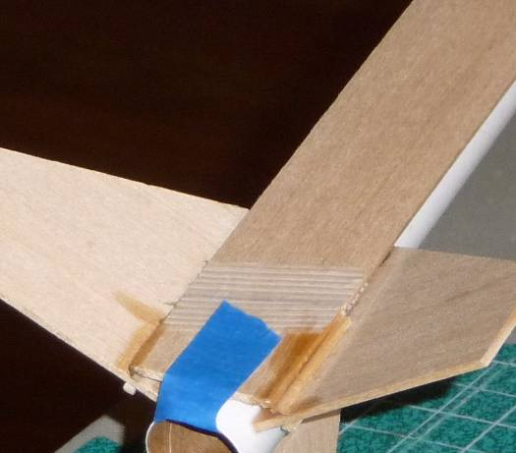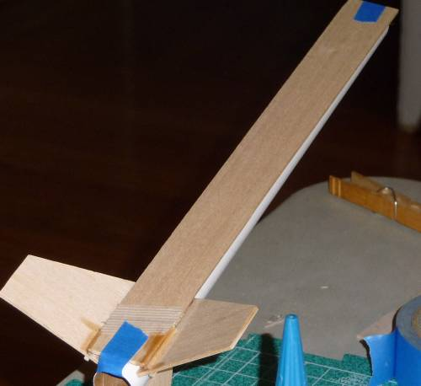 Repeat with other two rotors. There should be a small gap between the rotor and the fin. Apply small yellow glue fillets to the joints between the fins and the short part of the rotor for all six joints. The front of the rotors should align with the front of the body tube.
- Attach the rotor stops. Take one of G, and check how it fits across two of the fins. It will slant from the top of the end of one fin to the bottom of the end of the other. Use sandpaper to sand the ends so they sit flush with the fins. Use thin CA to glue it in place. Be sure you have it going in the right direction so the deployed rotor will sit against it correctly. Repeat with other three stops. 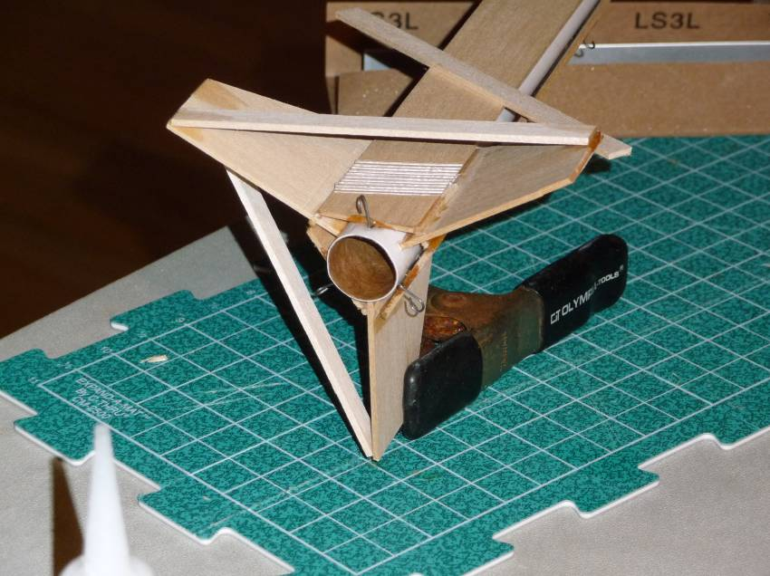
- Attach the rear hooks. Take one of H and insert it in the rear between a rotor and the body tube. Take it out, apply medium CA to the straight part of the hook and insert it back, with the hook perpidicular to the rotor. Use accelerator to set the CA. Repeat with the other two hooks. 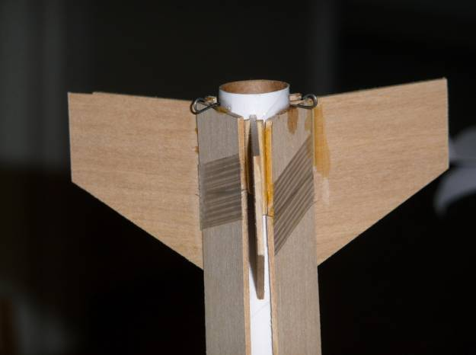
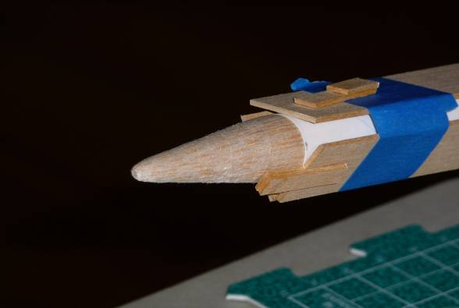
- Attach the rotor holds to the nose cone. Before this step, ensure that the nose cone slides easily in and out of the bodytube using sandpaper. Then, use a piece of masking tape around the rotors an inch back from the front of the body tube to hold the rotors down. Remove the tape used to hold the rotors during gluing. Place the nose cone into the body tube. Take one of the rotor holds and check how it will align with the rotor when glued to the nose cone. Holding the rotor hold in place, use a small drop of CA near the top of the rotor hold/nose cone contact to tack the hold in place. Use accelerator to set it. Repeat with other two rotor holds. Be very careful to not get glue where the rotor hold contacts the rotor. The rotor hold should align to the rotor, not the nose cone. This will leave a gap at the front. Don’t worry; we’ll fill that with epoxy in the next step.
- Apply epoxy in a few key places. Remove the nose cone from the body tube (hopefully it didn’t stick). Mix up some 5 min epoxy, and make a generous fillet around the rotor holds, especially in the gap at the front. And also apply epoxy at the joint between the stops and the fins. Use a toothpick to apply epoxy between the bodytube and the rotor at the rear, which will epoxy the rear hook at the same time. Apply epoxy on the front hooks. Finally, apply epoxy at the joints between the fins and the rotors. Be careful not to get any past the hinge line. This step could be postponed until you get home, but be gentle with the nosecone holds until then. 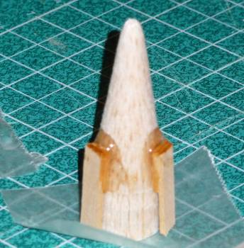.
- Put the screw eye into the center of the nose cone. Screw it all of the way in. Apply thin CA around the base of where the screw eye goes into the wood, to help strengthen the balsa. You can use accelerator to set the CA.
- Make the shock cord mount. Take Q, and fold it up along the lines. Take N, apply glue inside the shock cord mount, and fold up with the Kevlar string in the folds.
- Make the shock cord. Make a loop knot in the Kevlar string near the shock cord mount. Take one of the rubber bands and loop it through the loop knot and through itself to attach it. 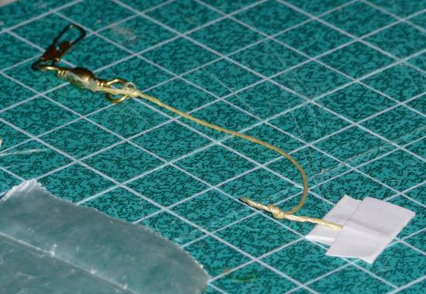
- Tie shock cord to the swivel. Tie the Kevlar string to the swivel hook. Run the rubber band through the swivel hook and over, so it is attached. Note that the rubber band should be shorter than the Kevlar string. The Kevlar string is intended as a safety in case the rubber band breaks or burns through (which it will) and also to reduce some of the back lash from the rubber band. Also note that the whole shock cord is quite short. This is intentional as a way to help the rotation by not having a long nose dangling from a string that tangles and throws the rotation off. 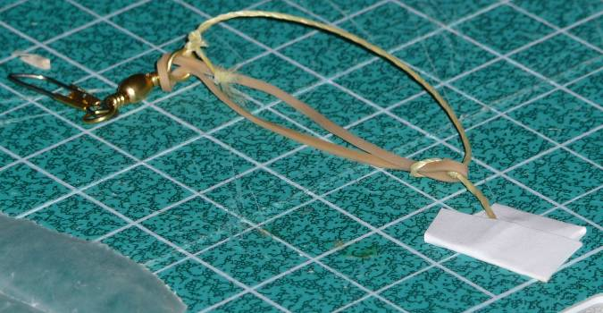
- Glue the shock cord mount to the body tube. Apply glue to the shock cord mount and glue it to the inside of the body tube at least and inch back from the front. Hold firmly in place with finger until set. Attach the swivel hook to the nose. 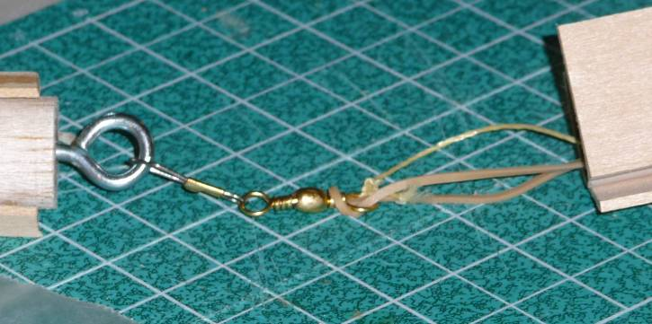
- Congratulations! You’re almost done. Take a step back, scratch your head and look at what you have. In the interest of a build session, we used lots of CA to expedite the construction. CA is great but the SunFlower can have some large forces on it, so we need to add some “real” glue to ensure things are strong enough. You can use yellow glue or epoxy. There are some places we already applied some small fillets, those were usually hard to reach places once constructed. The fillets are left as an exercise for home. I strongly suggest using a fillet on all joints you can reach, especially the rotor stops. Be careful not to glue the rotors to the tube or nose cone though.
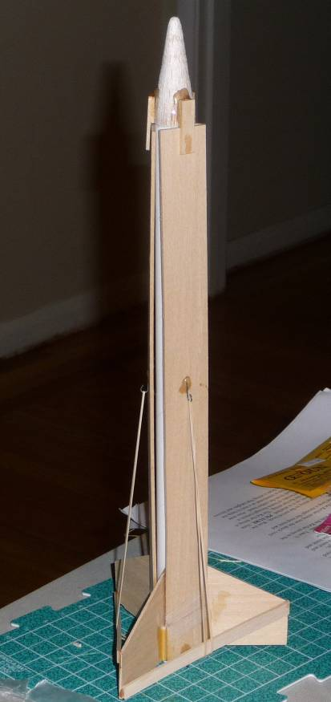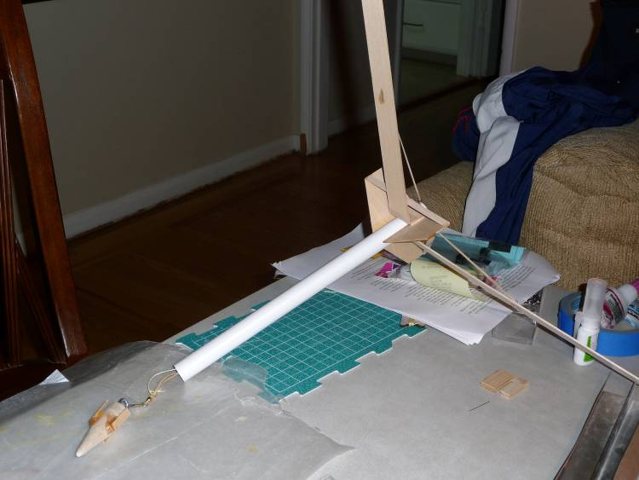

Finishing:
I called it the SunFlower because I painted the inside of the rotors gold and the outside green. I also didn’t bother to fill the basswood. I was looking for something quick. You’re welcome to finish it any way you like. With a build session it is tough, since much of the finish work should happen before building the model.

Flying:
- Place motor in against the thrust ring. Tape the motor sticking out to the body tube using masking tape around the end. If you’re fins are flush with the bottom of the tube, use tape to ensure the motor is tight enough to not kick at ejection. You can use A8-3, B6-4, B4-2, C6-5 (Perhaps an 18mm D, though I haven’t tried it).
- Put the nose cone on with the rotors up and held down by the rotor holds. Depending on how well your fins are aligned, you’re holds may only work in one alignment over the rotors. Note there is no need for wadding.
- Attach a rubber band from the bottom hook over the rotor stop and onto the rotor hook. Unlike standard helirocs, the rubber band doesn’t need to be pulling like crazy. Aerodynamics will help open the rotors, the rubber bands just ensure they get fully open. Repeat for the other two rotors.
- Place the launch rod between the fin, rotor mount, and body tube. It should go up beneath the rotor and out the top, clearing the rotor hold on the nose cone.
- Launch and enjoy. This isn’t a competition heliroc, but with a C6-5, it will be in the air for plenty of time.

IMPORTANT ADDENDUMS
- Just to re-iterate, there isn’t a separate launch lug. The launch lug is the gap between the fin, rotor, and body tube.
- Depending on how heavy the tail section is built, the CG can be back further than it would be otherwise. I would recommend getting a washer that will fit in a BT-20 and putting it between the screw eye and the nosecone. Or you can add some clay there as well. There have been a couple of cases of the Sunflower being unstable on larger motors.

